**FinSearch Mid-Term Report**

**Topic: Option pricing models and their accuracy**

**Group: E 10**

|  |  |  |
| --- | --- | --- |
| Sr No | Name | Roll No |
| 1 | Dattaraj Salunkhe | 22B1296 |
| 2 | Kshitij Bahadarpurkar | 22B1802 |
| 3 | Swayam Patel | 22B1816 |
| 4 | Priyansh Singh | 22B1856 |

The report consists of 3 sections:

1. The Black-Scholes Model: Working principles, assumptions for the model, advantages and limitations
2. The Binomial Model: Framework, working, assumptions, advantages and disadvantages
3. Comparison of both models on a dataset: The dataset consists of stock price and the corresponding option price on different days and both the models have been used to predict option prices and the predicted values are compared with the actual values
4. **The Black Scholes Model**

The Black–Scholes or Black–Scholes–Merton model is a mathematical model for the dynamics of a financial market containing derivative investment instruments. From the parabolic partial differential equation in the model, known as the Black–Scholes equation, one can deduce the Black–Scholes formula, which gives a theoretical estimate of the price of European-style options and shows that the option has a unique price given the risk of the security and its expected return.

1. **The Differential Equation**

The Black-Scholes Model is based on the following differential equation

$$\frac{∂V}{∂t}+\frac{1}{2}σ^{2}S^{2}\frac{∂^{2}V}{∂S^{2}}+rS\frac{∂V}{∂S}-rV=0$$

Where:

*V*: Price of the option

*S*: Price of the Stock

*r*: Risk free interest rate

*σ:* Volatility of the underlying asset (standard deviation of stock price’s return)

After Solving the Differential Equation, the price of a European Style option is given by

Call Option: $SN\left(d_{1}\right)-Ke^{-rT}N(d_{2})$

Put Option: $Ke^{-rT}N\left(-d_{2}\right)-SN\left(-d_{1}\right)$

In these Equations:

*K:* Strike Price of the option

*T:* Time for option Expiry

$d_{1}$: $\frac{\ln\left(\frac{S}{K}\right)+\left(r+\frac{σ^{2}}{2}\right)T}{σ\sqrt{T}}$

$d_{2}$: $d_{1}-σ\sqrt{T}$

*N*: Cumulative Standard Normal Distribution

It is defined as $N\left(x\right)=\frac{1}{\sqrt{2π}}\int_{-∞}^{x}{e^{\frac{-t^{2}}{2}}}dt$

1. **Assumptions for the Model to work**

* No dividends are paid out during the life of the option
* There are no transaction costs in buying the option
* The returns of the underlying asset are normally distributed
* The [risk-free rate](https://www.investopedia.com/terms/r/risk-freerate.asp) and volatility of the underlying asset are known and constant
* The asset prices follow a log-normal distribution

1. **Advantages of the Model**

* It provides a method to price options. Calculating option prices using modern computers is fairly simple. It provides a structured, defined method that is tried and tested
* By understanding the theoretical value of an option using the Black-Scholes model, investors can develop hedging strategies. This involves taking opposite positions in other instruments (like the underlying asset or other options) to offset potential risks associated with holding the initial option.
* It enhances efficiency in trading. Due to the Black-Scholes model, there is greater transparency in the market and traders have a better understanding of the factors affecting the pricing of options
* Since, it is a widely accepted model, it enhances consistency and compatibility across different markets and jurisdictions

1. **Disadvantages of the Model**

* Works only on European options. For American options that can be exercised before the expiry date, this simplistic model will not work
* The assumption that the stock provides no dividend makes it difficult to apply uniformly on all options
* The model also assumes that stock prices follow a log normal distribution and the volatility stays constant, which is not true especially when certain strong events tend to influence the markets

1. **The Binomial Model**
2. **Overview**

The Binomial Option Pricing Model is a popular method used to evaluate options. Unlike the Black-Scholes model, the binomial model provides a numerical method for the valuation of options, making it versatile for American options and other scenarios where early exercise might be optimal.

1. **Model Framework**

The binomial model divides the time to expiration into potentially a large number of time intervals or steps. At each step, the stock price can move up or down by a specific factor.

1. **Parameters and variables**

•*S*: Current stock price

•*K*: Strike price of the option

•*T*: Time to expiration

•*N*: Number of steps

•*r*: Risk-free interest rate

•*σ*: Volatility of the underlying asset

•*u*: Factor by which the price increases (up factor)

•*d*: Factor by which the price decreases (down factor)

•*p*: Risk-neutral probability of the price moving up

1. **Key Formulas**

* Up and down factors
$u=e^{σ\sqrt{\frac{T}{N}}}$

$d=\frac{1}{u}$

* Risk Neutral Probability

$p=\frac{e^{r(\frac{T}{N})}-d}{u-d}$

1. **Steps of the Binomial Model**

* Initialisation
* Set up a binomial tree representing possible paths the stock price could take at each step.
* Recursive Calculation

$S_{j}=S_{0}u^{2j-N}$

Where N is the step number and j vary from 0 to N

* Option Valuation at Maturity
* $C\left(S_{T}\right)=\max\left(S_{T}-K,0\right)$ for call option
* $P\left(S_{T}\right)=\max\left(K-S_{T},0\right)$ for put option
* Backward Induction
* Calculate the option price at each node by discounting the expected payoff from the next step

$C_{i,j}=e^{-r\left(\frac{T}{N}\right)}(pC_{i+1,j+1}+\left(1-p\right)C_{i+1,j})$

$P_{i,j}=e^{-r\left(\frac{T}{N}\right)}(pP_{i+1,j+1}+\left(1-p\right)P_{i+1,j})$

1. **Assumptions**

* The market is frictionless (no transaction costs or taxes).
* The risk-free rate and volatility are constant over the option’s life.
* The underlying asset does not pay dividends.
* The option can only be exercised at discrete points in time.

1. **Advantages**

* Flexibility
* Can be used for both European and American options.
* Suitable for options with complex features, like barriers and varying interest rates.
* Early Exercise Feature
* Handles American options, allowing for early exercise decisions.
* Intuitive
* Provides a clear and structured approach to option pricing, facilitating understanding and implementation.

1. **Disadvantages**

* Computational Intensity
  + As the number of steps increases, the computations become more intensive, potentially requiring significant processing power.
* Simplifying Assumptions
  + Assumes constant volatility and interest rates, which may not reflect real market conditions.
* Model Sensitivity
  + Highly sensitive to input parameters such as volatility and interest rates, leading to potential inaccuracies in valuation.

1. **Conclusion**

* The Binomial Option Pricing Model is a powerful tool for valuing options, particularly those that allow for early exercise. Its step-by-step approach offers flexibility and clarity, though it requires careful consideration of input parameters and computational resources.

1. **Comparison of the Models**

Both of the models have been compared using the dataset of Reliance obtained from the NSE website.

Link: <https://www.nseindia.com/get-quotes/derivatives?symbol=RELIANCE>

It consists of both put and call options of the following types:

* **Reliance Dataset 1**: K constant @ 2400, expiry date as 28 dec 2023, for the year 2023
* **Reliance Dataset 2**: K constant @ 2500, expiry date as 28 dec 2023, for the year 2023
* **Reliance Dataset 3**: K constant @ 2600, expiry date as 28 dec 2023, for the year 2023

To calculated the volatility the logarithm of stock price ratio between consecutive days was calculated. The standard deviation of the ratios was multiplied by the square root of the number of days to obtain the volatility of the stock.

The risk-free rate was assumed to be $7\% p.a$

1. Observations

The following graphs were obtained as a result of using the models

* Plot of predicted and actual price along with Mean Square Error (figure 1)
* Plot of the MSE error of the Binomial Model with respect to number of steps (figure 2)
* Considering the predicted and actual prices as vectors, the cosine between them gets closer to 1 as we increase the number of steps in the binomial model (figure 3)

(These graphs are also available on the github page)

1. Conclusion

* The Binomial Model and Black-Scholes model are fairly accurate and the Mean Square Error with respect to the actual prices are close
* As we increase the number of steps, the binomial MSE gets closer and closer to the black-scholes MSE with some oscillations with damping amplitudes as seen in figure 2
* The MSE also depends largely on moneyness of the option. The dataset 3 remains out of the money/ in the money for call/put options and thus shows low error. Whereas the dataset 1 which keeps on changing its moneyness shows slightly large error

1. Link to the Code:

https://github.com/priyanshsingh1765/Options-pricing-models-and-their-accuracy

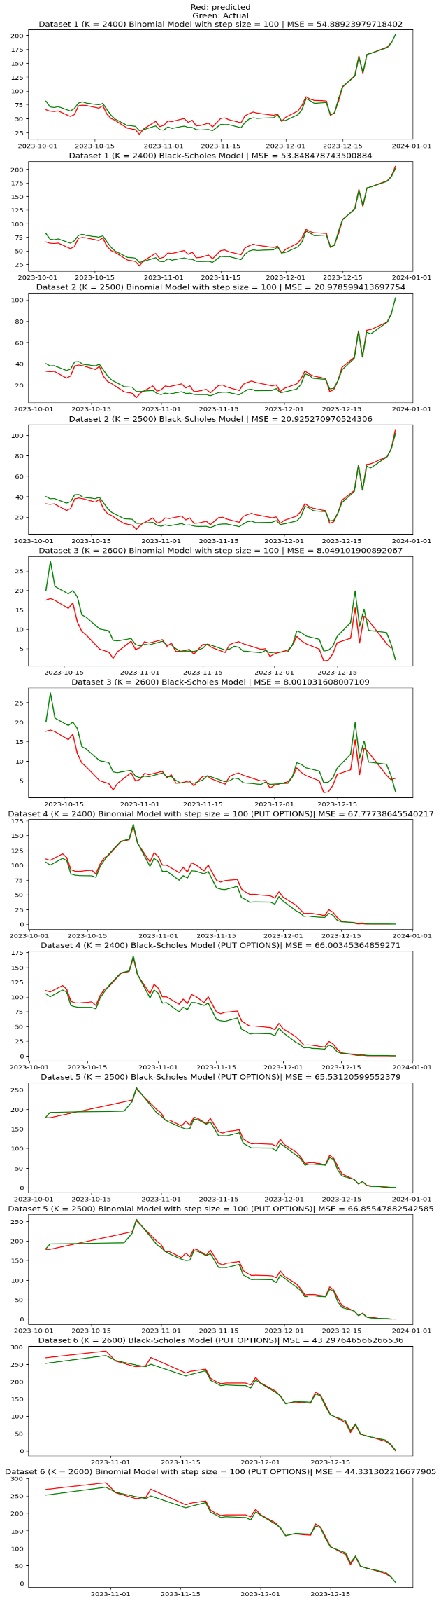 Figure 1

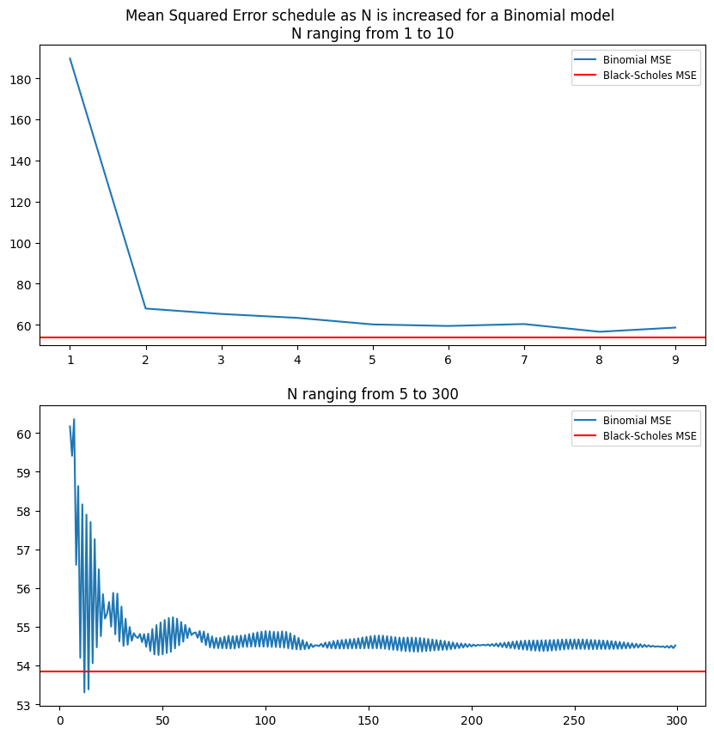

Figure 2

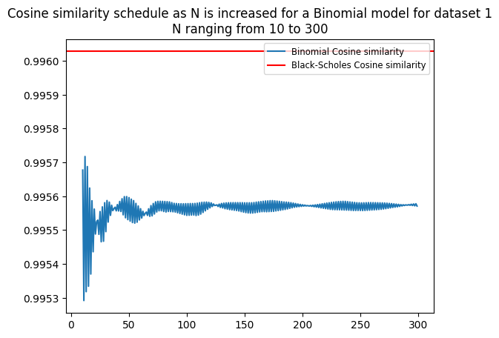

Figure 3